

**Orient DC Inverter Inventage 1.5 Ton**

**Rs. 60,000/-**

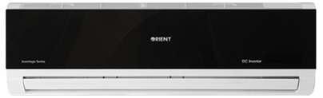

**Product Features**

* Multi- Mode for Installation
* Free Setting of Air Discharge Duct
* dry function
* wide voltage
* active PFC technology

**Specification**

**Type** Wall Mounted Split AC

**Cooling (Btu/h)** 47000

**Voltage (V)** 220-240

**Power Input (W)** 5200

**EER (Btu/W-h-W/W)** 6.2-2.1